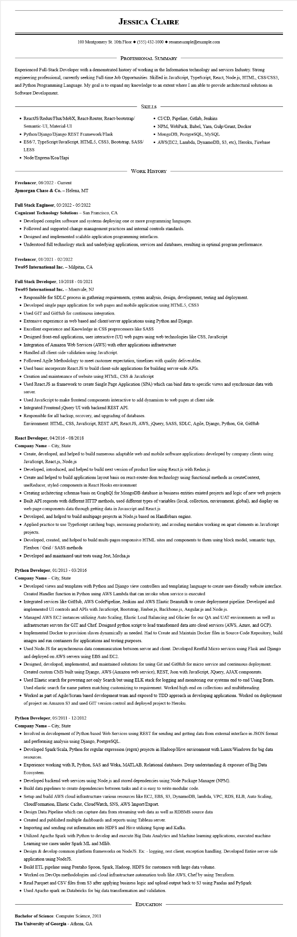
JESSICA CLAIRE
100 Montgomery St. 10th Floor (555) 432-1000◆ resumesample@example.com
PROFESSIONAL SUMMARY
Experienced Full-Stack Developer with a demonstrated history of working in the Information technology and services Industry. Strong engineering professional, currently seeking Full-time Job Opportunities. Skilled in JavaScript, TypeScript, React, Node.js, HTML, CSS/CSS3, and Python Programming Language. My goal is to expand my knowledge to an extent where I am able to provide architectural solutions in Software Development.
SKILLS
• ReactJS/Redux/Flux/MobX, React-Router, React-bootstrap/
Semantic-UI, Material-UI
• Python/Django/Django REST Framework/Flask
• ES6/7, TypeScript/JavaScript, HTML5, CSS3, Bootstrap, SASS/ LESS
• Node/Express/Koa/Hapi
• CI/CD, Pipeline, Gitlab, Jenkins
• NPM, WebPack, Babel, Yarn, Gulp/Grunt, Docker
• MongoDB, PostgreSQL, MySQL
• AWS(EC2, Lambda, DynamoDB, S3, etc), Heroku, Firebase
WORK HISTORY
Freelancer, 06/2022 - Current
Jpmorgan Chase & Co. - Helena, MT
Full Stack Engineer, 03/2022 - 05/2022
Cognizant Technology Solutions - San Francisco, CA
• Developed complex software and systems deploying one or more programming languages.
• Followed and supported change management practices and internal controls standards.
• Designed and implemented scalable application programming interfaces.
• Understood full technology stack and underlying applications, services and databases, resulting in optimal program performance.
Freelancer, 01/2021 - 02/2022
Two95 International Inc. - Milpitas, CA
Full Stack Developer, 10/2018 - 01/2021
Two95 International Inc. - Montvale, NJ
• Responsible for SDLC process in gathering requirements, system analysis, design, development, testing and deployment.
• Developed single page application for web pages and mobile application using HTML5, CSS3
• Used GIT and GitHub for continuous integration.
• Extensive experience in web based and client/server applications using Python and Django.
• Excellent experience and Knowledge in CSS preprocessors like SASS
• Designed front-end applications, user interactive (UI) web pages using web technologies like CSS, JavaScript
• Integration of Amazon Web Services (AWS) with other applications infrastructure
• Handled all client-side validation using JavaScript.
• Followed Agile Methodology to meet customer expectation, timelines with quality deliverables.
• Used basic incorporate React.JS to build client-side applications for building server-side APIs.
• Creation and maintenance of website using HTML, CSS & JavaScript
• Used React.JS as framework to create Single Page Application (SPA) which can bind data to specific views and synchronize data with
server.
• Used JavaScript to make frontend components interactive to add dynamism to web pages at client side.
• Integrated Frontend jQuery UI with backend REST API.
• Responsible for all backup, recovery, and upgrading of databases.
Environment: HTML, CSS, JavaScript, REST API, React.JS, AWS, jQuery, SASS, SDLC, Agile, Django, Python, Git, GitHub
React Developer, 04/2016 - 08/2018
Company Name - City, State
• Create, developed, and helped to build numerous adaptable web and mobile software applications developed by company clients using JavaScript, React.js, Node.js
• Developed, introduced, and helped to build next version of product line using React.js with Redux.js
• Create and helped to build applications layout basis on react-router-dom technology using functional methods as createContext, useReducer, styled-components in React Hooks environment
• Creating architecting schemas basis on GraphQ1 for MongoDB database in business entities existed projects and logic of new web projects
• Built API requests with different HTTP methods, used different types of variables (local, collection, environment, global), and display on web page components data through getting data in Javascript and React.js
• Developed, and helped to build multipage projects in Node.js based on Handlebars engine.
• Applied practice to use TypeScript catching bugs, increasing productivity, and avoiding mistakes working on apart elements in JavaScript projects.
• Developed, created, and helped to build multi-pages responsive HTML sites and components to them using block model, semantic tags, Flexbox / Grid/ SASS methods
• Developed and maintained unit tests using Jest, Mocha.js
Python Developer, 01/2013 - 03/2016
Company Name - City, State
• Developed views and templates with Python and Django view controllers and templating language to create user-friendly website interface. Created Handler function in Python using AWS Lambda that can invoke when service is executed
• Integrated services like GitHub, AWS CodePipeline, Jenkins and AWS Elastic Beanstalk to create deployment pipeline. Developed and implemented UI controls and APIs with JavaScript, Bootstrap, Ember.js, Backbone.js, Angular.js and Node.js.
• Managed AWS EC2 instances utilizing Auto Scaling, Elastic Load Balancing and Glacier for our QA and UAT environments as well as infrastructure servers for GIT and Chef. Designed python script to load transformed data into cloud services (AWS, Azure, and GCP).
• Implemented Docker to provision slaves dynamically as needed. Had to Create and Maintain Docker files in Source Code Repository, build images and run containers for applications and testing purposes.
• Used Node.JS for asynchronous data communication between server and client. Developed Restful Micro services using Flask and Django and deployed on AWS servers using EBS and EC2.
• Designed, developed, implemented, and maintained solutions for using Git and GitHub for micro service and continuous deployment. Created custom CMS built using Django, AWS (Amazon web service), REST, Json with JavaScript, JQuery, AJAX components.
• Used Elastic search for powering not only Search but using ELK stack for logging and monitoring our systems end to end Using Beats. Used elastic search for name pattern matching customizing to requirement. Worked high-end on collections and multithreading.
• Worked as part of Agile/Scrum based development team and exposed to TDD approach in developing applications. Worked on deployment of project on Amazon S3 and used GIT version control and deployed project to Heroku.
Python Developer, 05/2011 - 12/2012
Company Name - City, State
• Involved in development of Python based Web Services using REST for sending and getting data from external interface in JSON format and performing analysis using Django, PostgreSQL.
• Developed Spark/Scala, Python for regular expression (regex) projects in Hadoop/Hive environment with Linux/Windows for big data
resources.
• Experience working with R, Python, SAS and Weka, MATLAB, Relational databases. Deep understanding & exposure of Big Data
Ecosystem.
• Developed backend web services using Node.js and stored dependencies using Node Package Manager (NPM).
• Build data pipelines to create dependencies between tasks and it is easy to write modular code.
• Setup and build AWS cloud infrastructure various resources like EC2, EBS, S3, DynamoDB, lambda, VPC, RDS, ELB, Auto Scaling, CloudFormation, Elastic Cache, CloudWatch, SNS, AWS Import/Export.
• Design Data Pipeline which can capture data from streaming web data as well as RDBMS source data
• Created and published multiple dashboards and reports using Tableau server.
• Importing and sending out information into HDFS and Hive utilizing Sqoop and Kafka.
• Utilized Apache Spark with Python to develop and execute Big Data Analytics and Machine learning applications, executed machine Learning use cases under Spark ML and Milib.
• Design & develop common platform frameworks on NodeJS. Ex: - logging, rest client, exception handling. Developed Entire server-side application using NodeJS.
• Build ETL pipeline using Pentaho Spoon, Spark, Hadoop, HDFS for customers with large data volume.
• Worked on DevOps methodologies and cloud infrastructure automation tools like AWS, Chef by using Terraform.
• Read Parquet and CSV files from $3 after applying business logic and upload output back to $3 using Pandas and PySpark
• Used Apache spark on Databricks for big data transformation and validation.
Bachelor of Science: Computer Science, 2011
The University of Georgia - Athens, GA
EDUCATION

